GRAPH ALGORITHMS
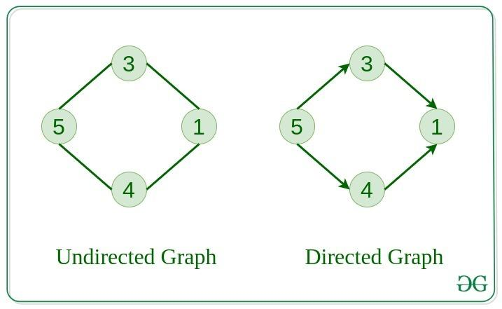
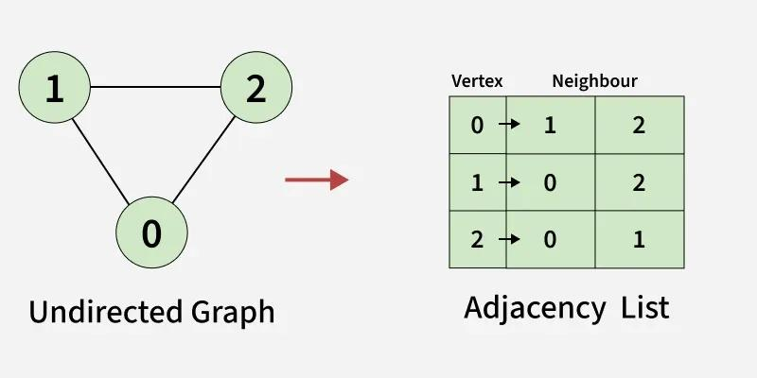
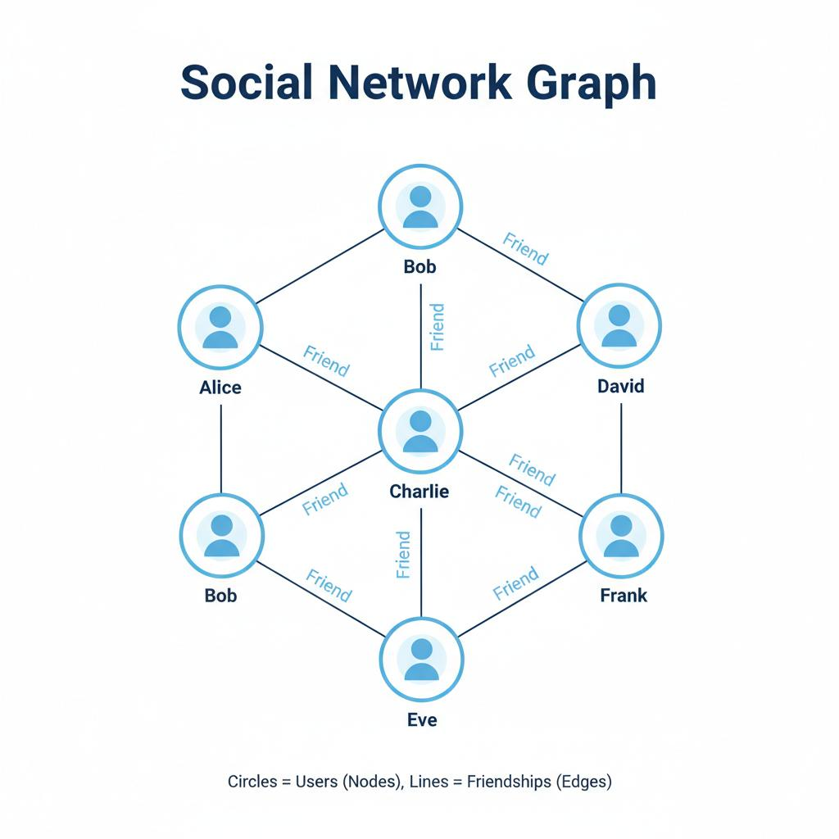
7
✅ Definition
A Graph is a non-linear data structure consisting of:
- Vertices (V) → nodes
- Edges (E) → connections between nodes

📘 Why Graph?
- Tree → only hierarchical
- Graph → random connections
👉 Used in:
- Social networks
- GPS navigation
- Computer networks

🔷 GRAPH REPRESENTATION
🔹 1. Adjacency Matrix
- 2D array
- Space: O(V²)
🔹 2. Adjacency List
- List of neighbors
- Space: O(V + E) (efficient)

🔷 1. GRAPH TRAVERSAL

🔹 Breadth First Search (BFS)
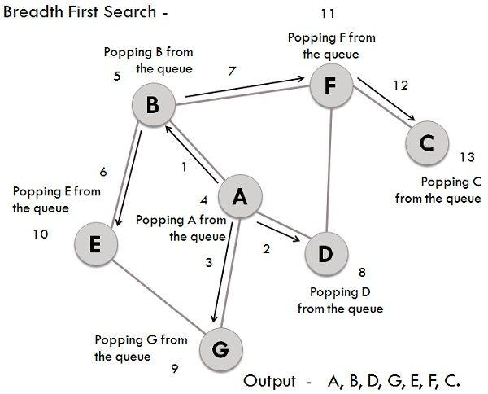
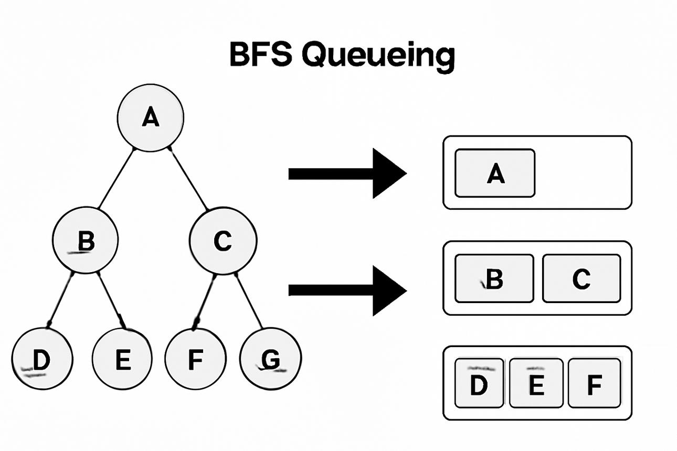
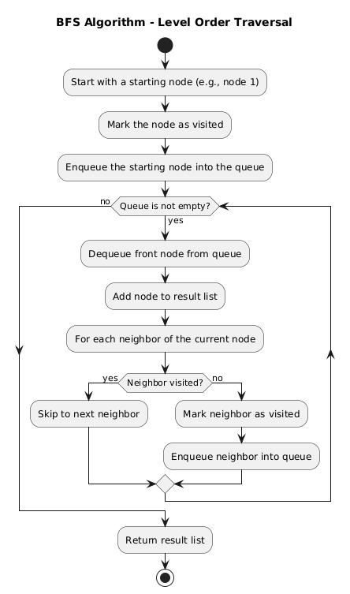
7
⚙️ Working
Explore nodes level by level
📌 Steps
- Start from source
- Use queue
- Mark visited
- Visit neighbors
- Repeat
⏱ TC: O(V + E)
💾 SC: O(V)

🔹 Depth First Search (DFS)
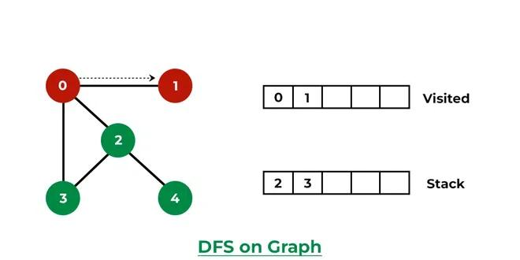
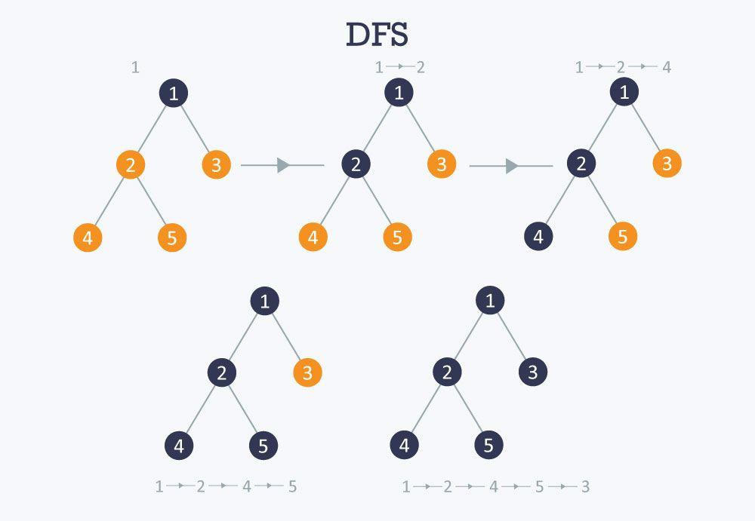
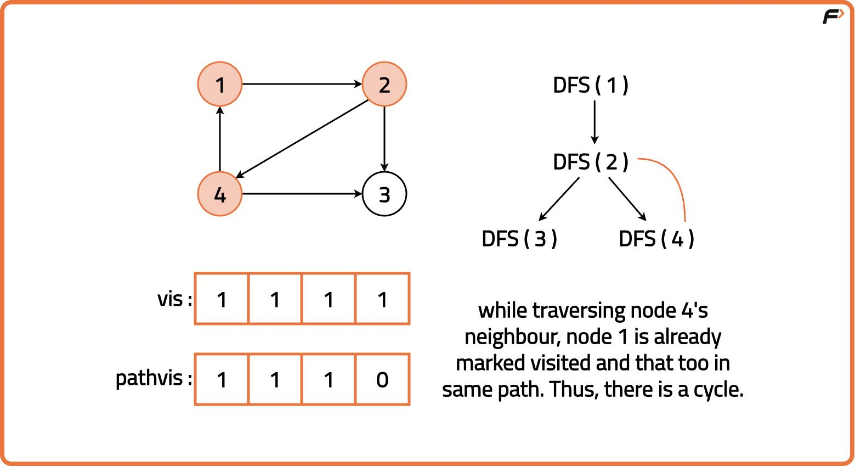
6
⚙️ Working
Explore deep first then backtrack
📌 Steps
- Start from node
- Visit node
- Go deeper recursively
- Backtrack
⏱ TC: O(V + E)
💾 SC: O(V)

⚖️ BFS vs DFS
Feature | BFS | DFS
Structure | Queue | Stack
Path | Shortest | Not guaranteed
Use | Level traversal | Backtracking

🔷 2. SHORTEST PATH ALGORITHMS

🔹 Dijkstra
- Works for non-negative weights
- Greedy approach
Steps
- Pick minimum distance node
- Relax edges
TC: O(E log V)

🔹 Bellman-Ford
- Handles negative weights
Steps
- Relax edges V-1 times
- Detect negative cycle
TC: O(VE)

🔹 Floyd Warshall
- All-pairs shortest path
TC: O(V³)

🔷 3. MINIMUM SPANNING TREE (MST)

🔹 Prim’s Algorithm
- Grow tree
TC: O(E log V)

🔹 Kruskal’s Algorithm
- Pick smallest edges
TC: O(E log E)

🔷 4. TOPOLOGICAL SORT
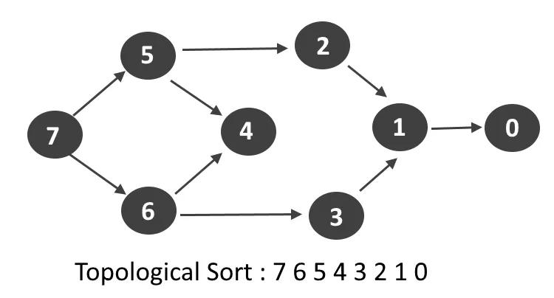
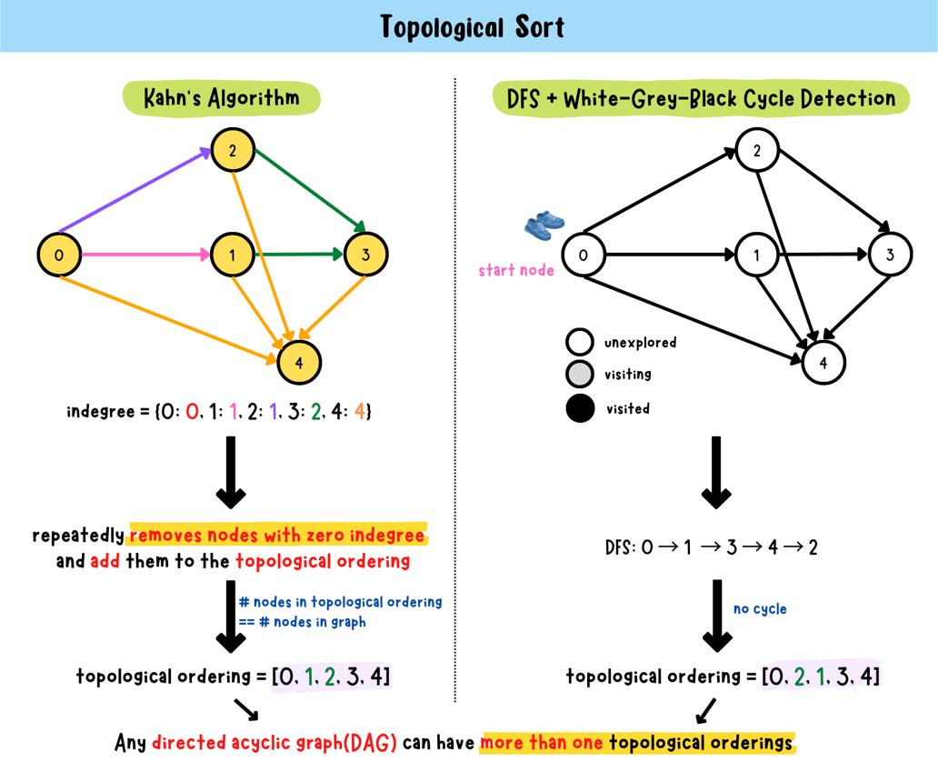
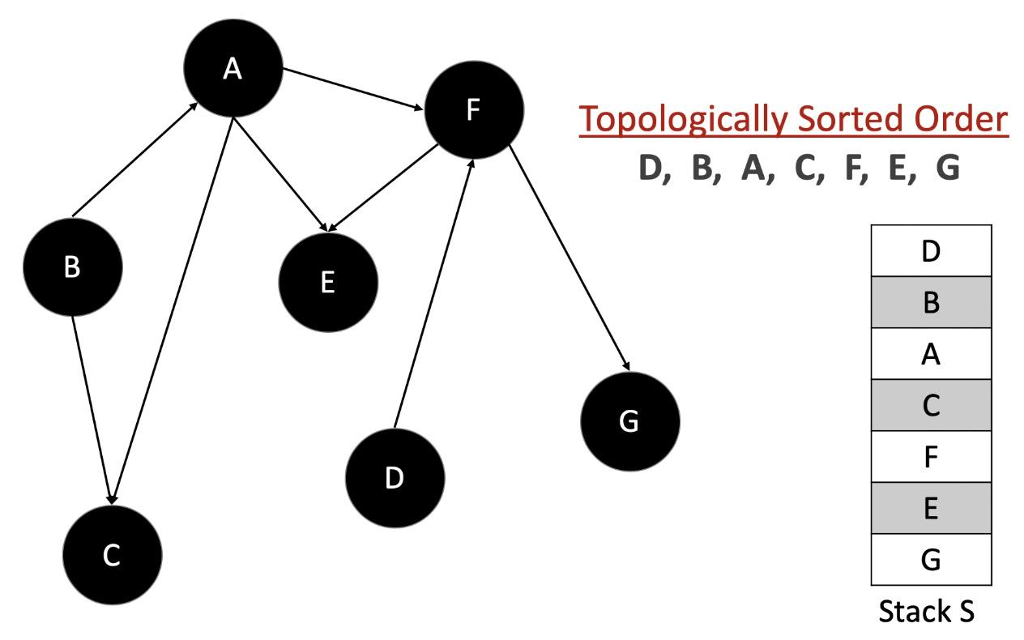
6
✅ Definition
Linear ordering of vertices in DAG

🔹 Kahn’s Algorithm (BFS based)
Steps
- Calculate indegree
- Add 0 indegree nodes
- Remove and update

🔷 5. CYCLES IN GRAPH

🔹 Directed Graph
- Use DFS + recursion stack
🔹 Undirected Graph
- Use DFS + parent check
🔹 Negative Cycle
- Use Bellman-Ford

🔷 6. CONNECTIVITY

🔹 Strongly Connected Components
- Use Tarjan / Kosaraju

🔹 Bridges & Articulation Points
- Critical connections

🔷 7. DISJOINT SET (UNION-FIND)
⚙️ Working
- Union + Find
Use
- Cycle detection
- Kruskal

🔷 8. SPECIAL PROBLEMS (IMPORTANT)
- Flood Fill
- Word Ladder
- Snake & Ladder
- Water Jug
- Rotten Oranges
- Islands Problem
👉 Mostly solved using BFS/DFS

🔷 9. MAX FLOW

🔹 Ford-Fulkerson
- Augmenting path
TC: O(max_flow × E)

🔹 Dinic Algorithm
- Faster version

🔷 10. IMPORTANT POINTS
✔ BFS → shortest path (unweighted)
✔ DFS → recursion/backtracking
✔ Dijkstra → no negative weights
✔ Bellman-Ford → detects negative cycle
✔ MST → Prim & Kruskal
✔ DAG → Topological Sort

🧠 FINAL MEMORY MAP
- Traversal → BFS, DFS
- Shortest Path → Dijkstra, Bellman
- MST → Prim, Kruskal
- DAG → Topological
- Connectivity → SCC, Bridges
- Flow → Ford-Fulkerson

🧾 FINAL 5-LINE EXAM ANSWER
- Graph = vertices + edges
- Used for real-world networks
- BFS & DFS are basic traversals
- Dijkstra, Bellman → shortest path
- Prim, Kruskal → MST

🧠 🔷 1. BFS (Breadth First Search)
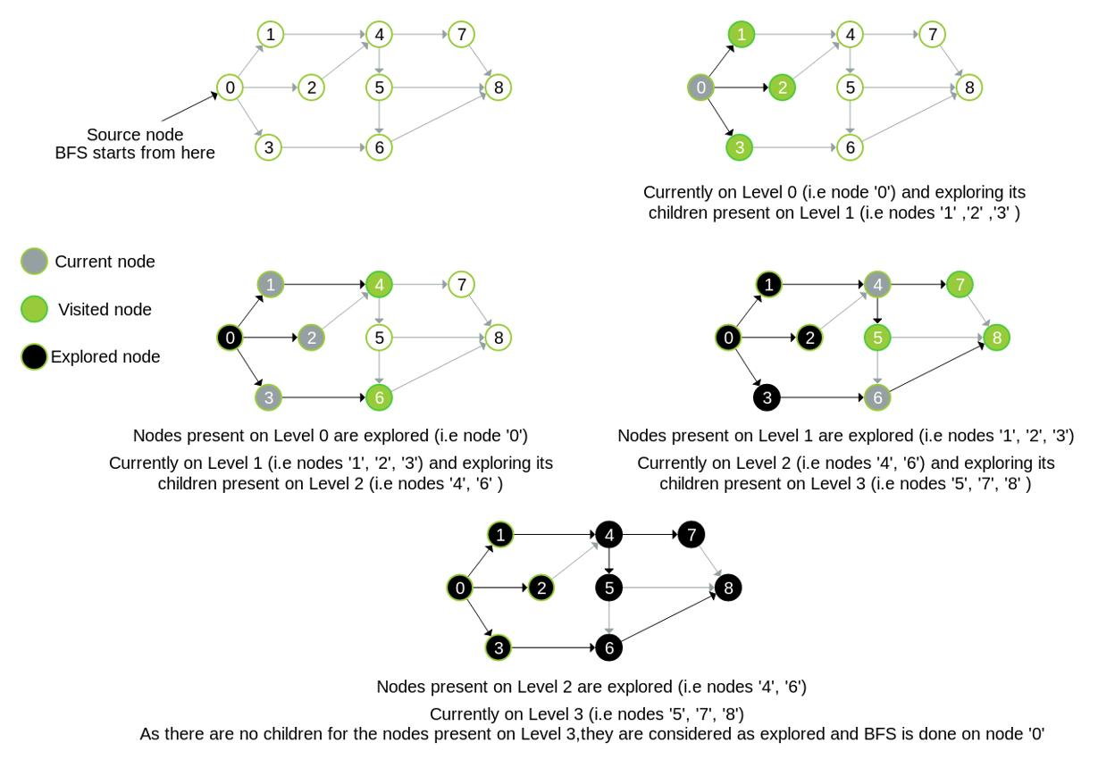
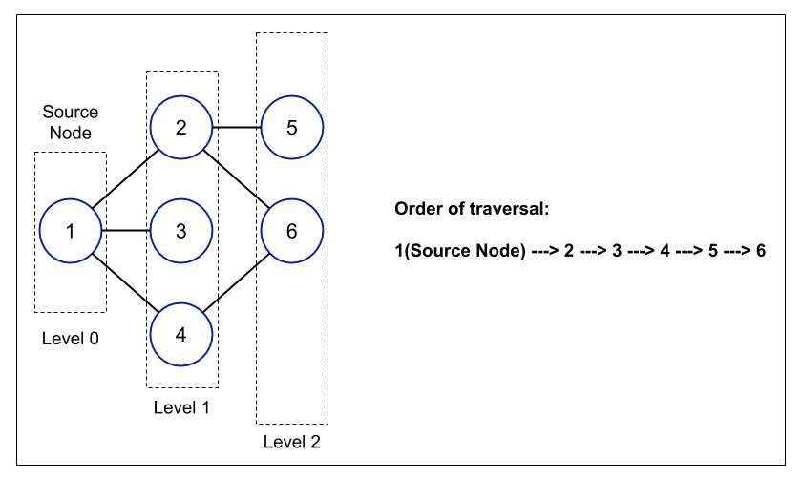
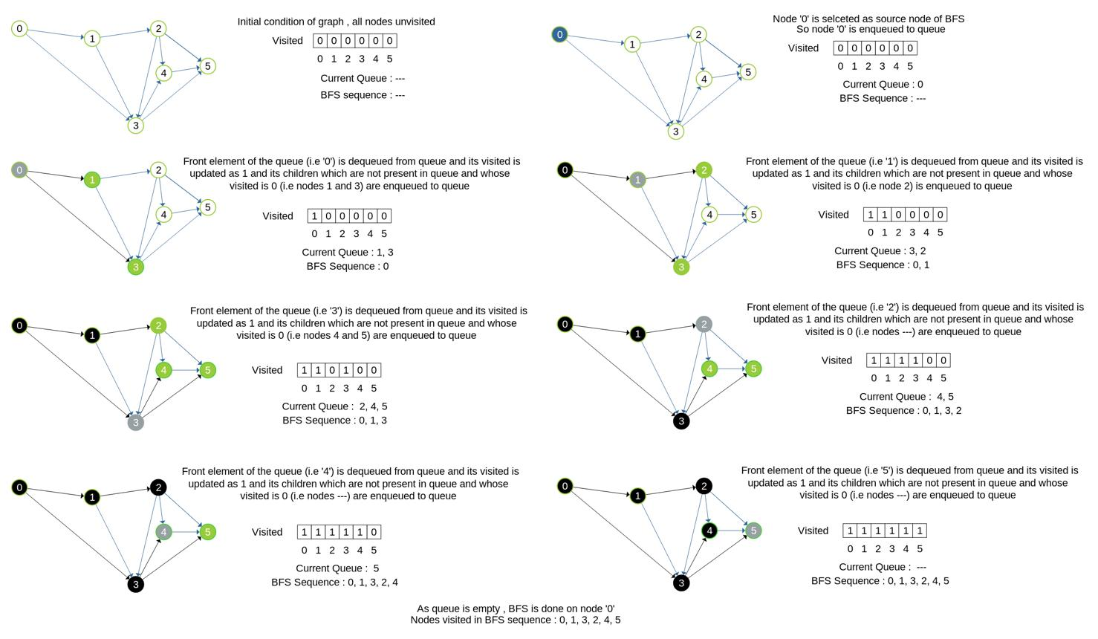
7
⚙️ Working Idea
Traverse level by level using a queue
📌 Solving Steps
- Start from source node
- Mark it visited
- Add to queue
- Remove front node
- Visit all unvisited neighbors
- Add them to queue
- Repeat until queue empty
👉 Order = Level-wise traversal

🧠 🔷 2. DFS (Depth First Search)
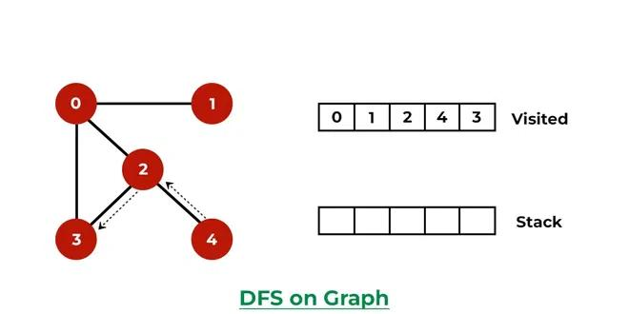
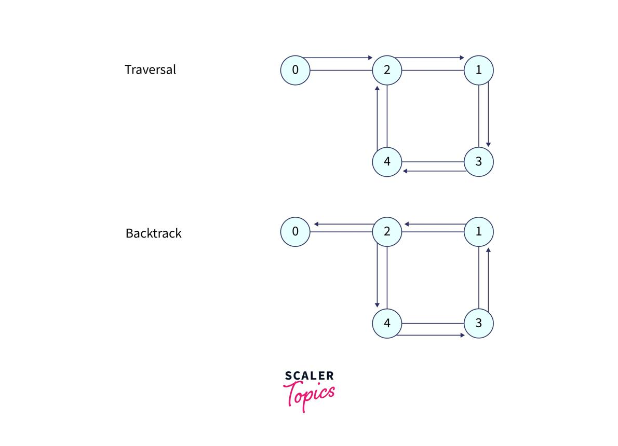

6
⚙️ Working Idea
Go deep first, then backtrack
📌 Solving Steps
- Start from node
- Mark visited
- Visit one neighbor
- Go deeper recursively
- If no neighbor → backtrack
- Repeat
👉 Uses recursion/stack

🧠 🔷 3. Dijkstra Algorithm (Shortest Path)
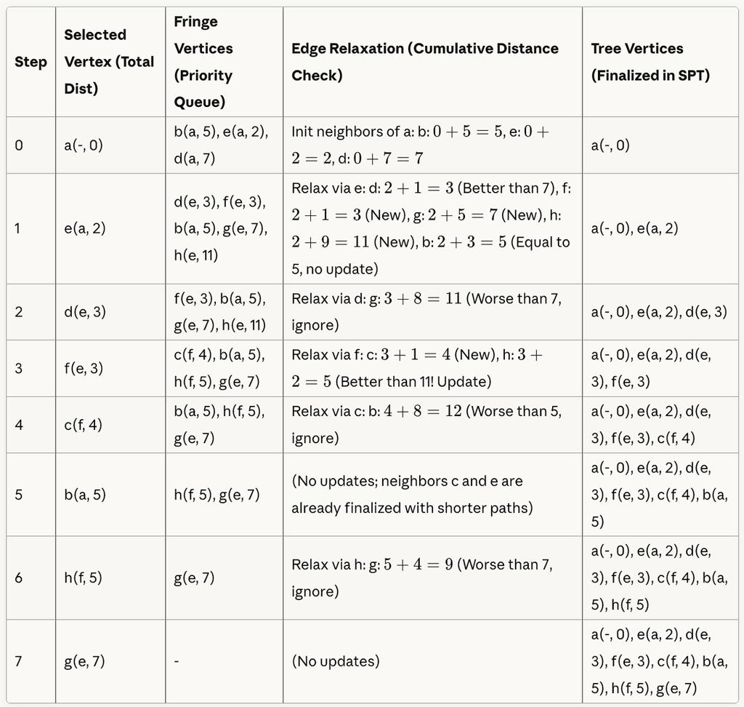
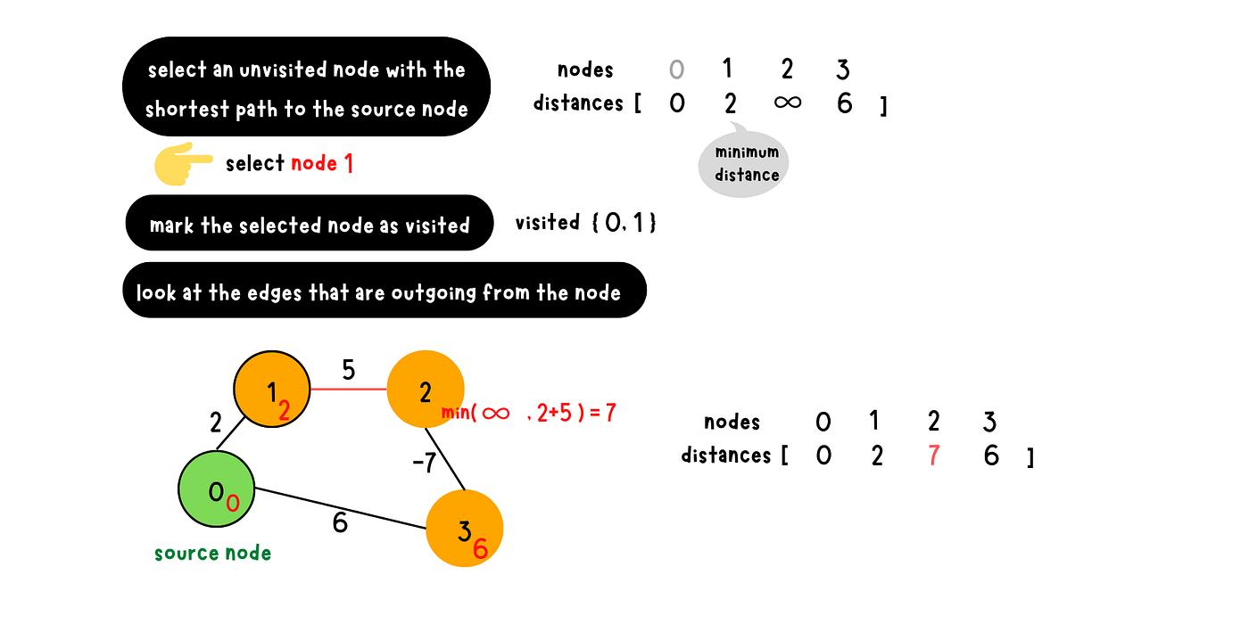
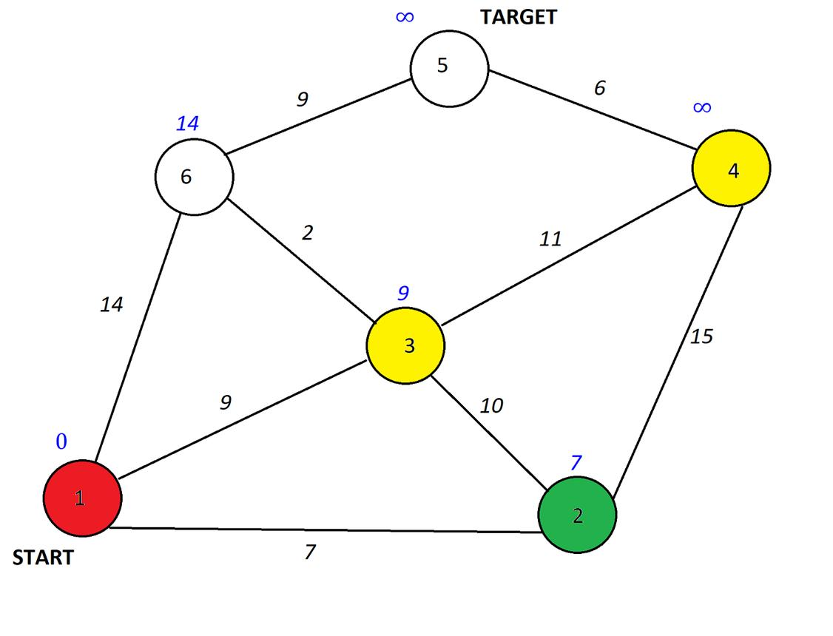
6
⚙️ Working Idea
Pick nearest node and update distances
📌 Solving Steps
- Set all distances = ∞, source = 0
- Pick node with minimum distance
- Mark it visited
- Update neighbors:
new_dist = current + edge weight
- Repeat
👉 Final distances = shortest path

🧠 🔷 4. Kruskal Algorithm (MST)
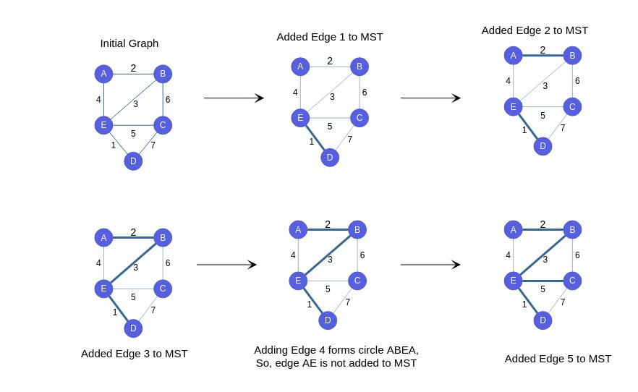
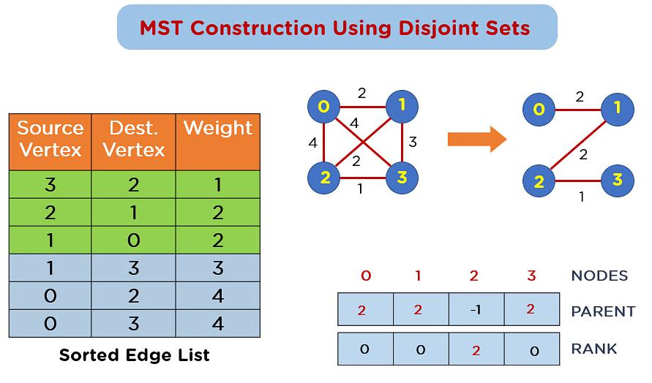
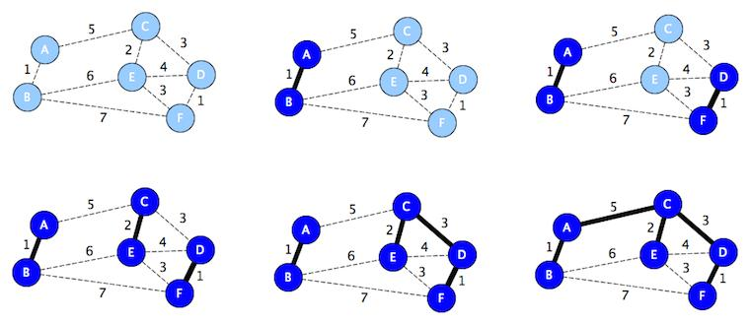
7
⚙️ Working Idea
Pick smallest edges without cycle
📌 Solving Steps
- Sort all edges by weight
- Start with empty MST
- Pick smallest edge
- Check cycle (Union-Find)
- If no cycle → include
- Repeat until V-1 edges

🧠 🔷 5. Prim’s Algorithm (MST)
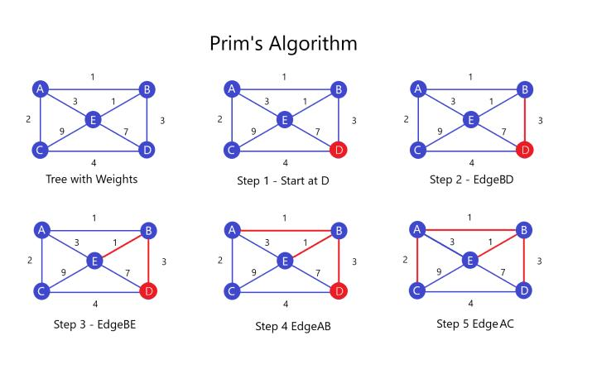
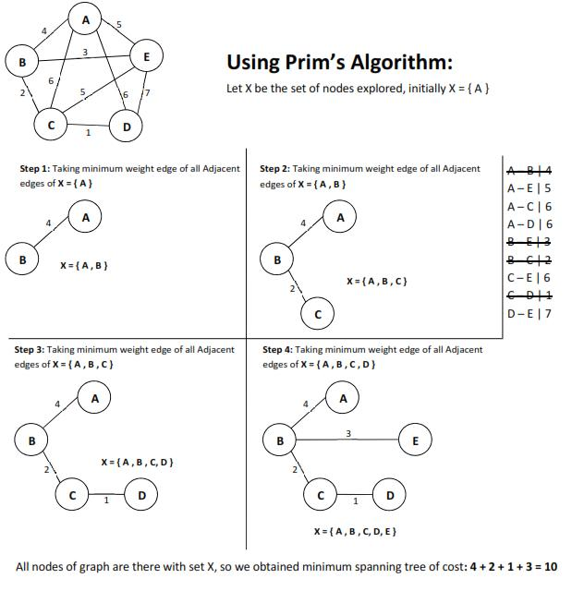
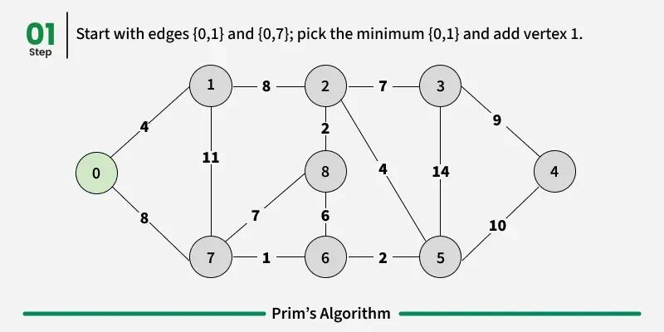
5
⚙️ Working Idea
Grow MST from a node
📌 Solving Steps
- Start from any node
- Mark visited
- Pick smallest edge connecting visited → unvisited
- Add edge
- Mark node visited
- Repeat

🧠 🔷 6. Topological Sort (Kahn’s Algorithm)
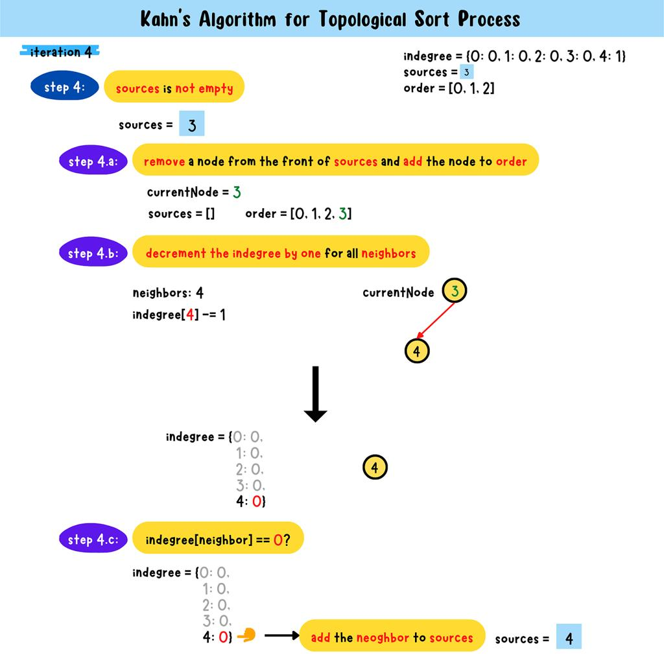
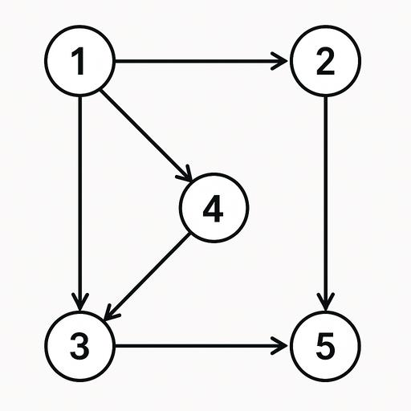
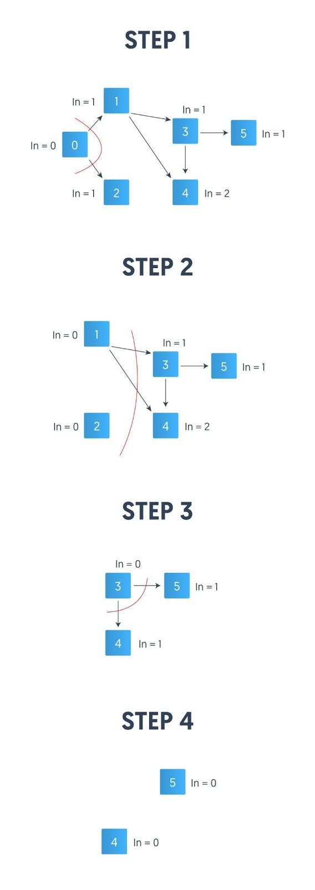
8
⚙️ Working Idea
Order nodes with no dependency first
📌 Solving Steps
- Calculate indegree of all nodes
- Add nodes with indegree = 0 to queue
- Remove node
- Reduce indegree of neighbors
- Add new 0 indegree nodes
- Repeat

🧠 🔷 7. Bellman-Ford (Shortest Path)
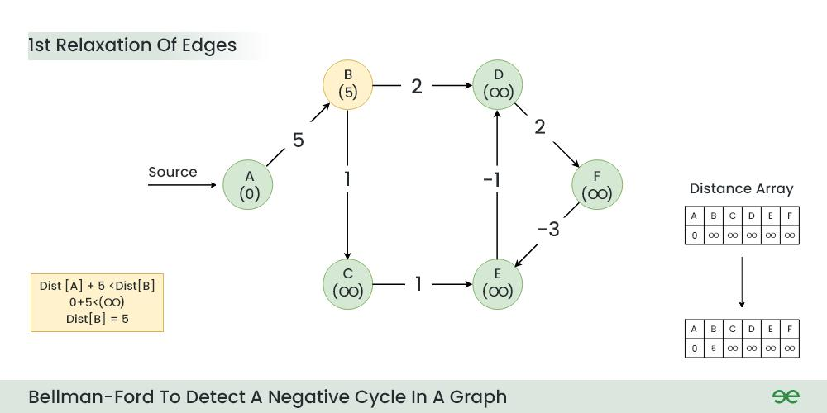
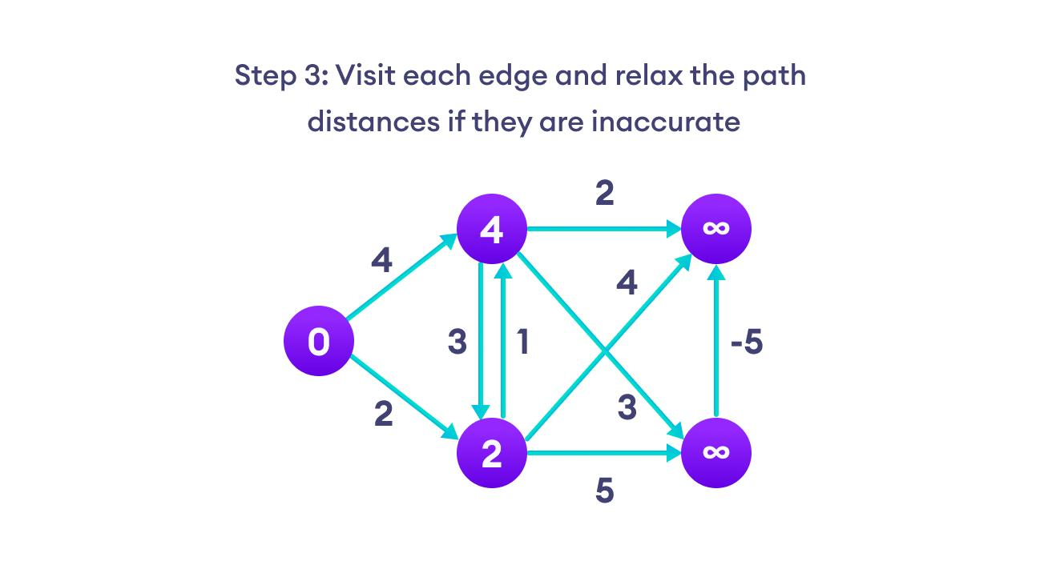
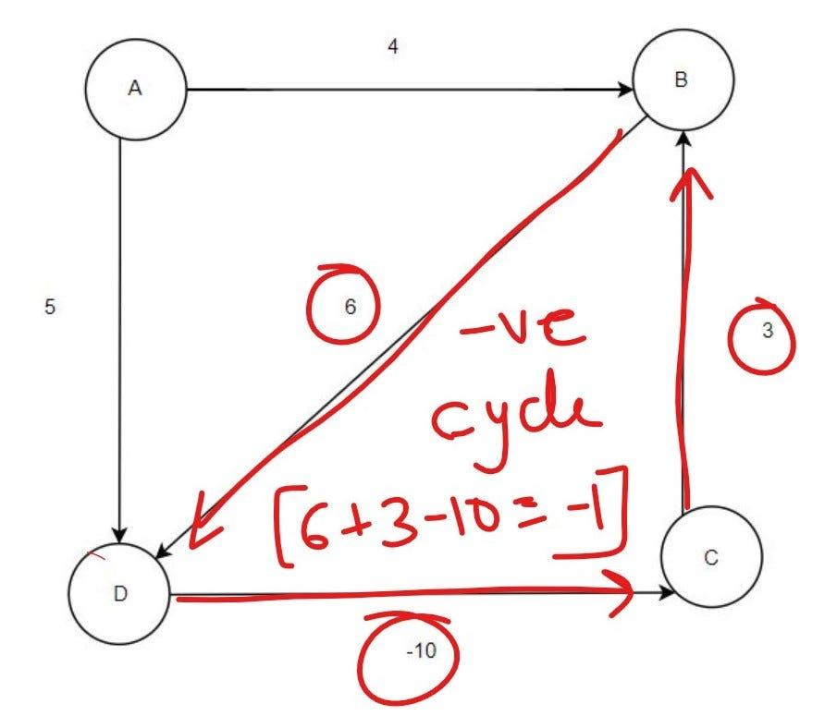
6
⚙️ Working Idea
Relax all edges multiple times
📌 Solving Steps
- Initialize distances
- Repeat V-1 times:
update all edges
- Check one more time:
if update → negative cycle

🧠 🔷 8. Floyd Warshall
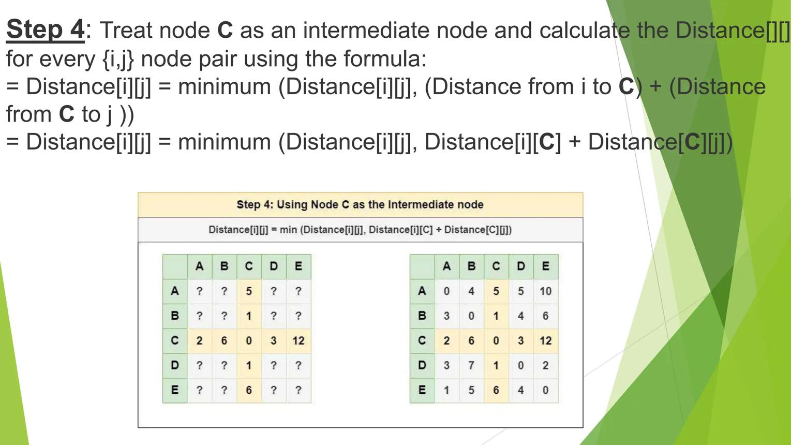
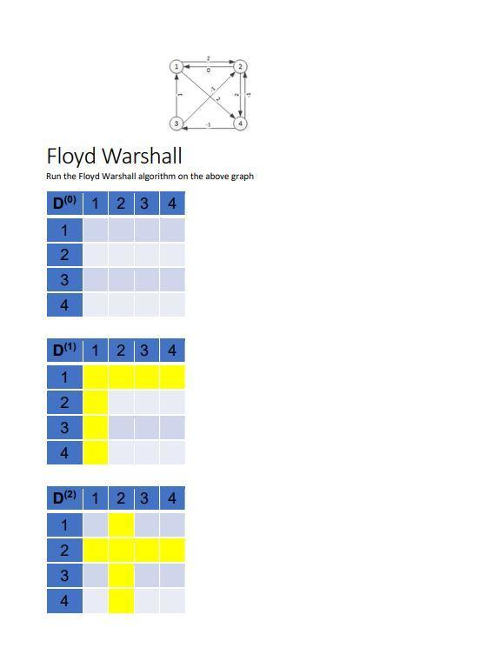
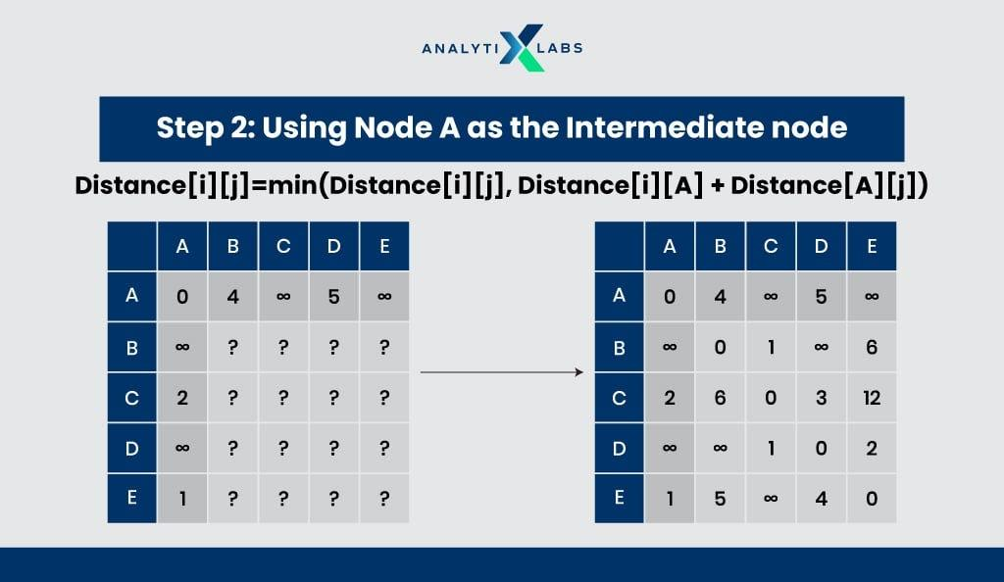
6
⚙️ Working Idea
Use intermediate nodes
📌 Solving Steps
- Initialize matrix
- For each k (node):
update distance[i][j] =
min(d[i][j], d[i][k] + d[k][j])
- Repeat for all nodes

🧠 FINAL QUICK MEMORY
Algorithm | Key Step
BFS | Queue, level
DFS | Recursion
Dijkstra | Min distance
Kruskal | Sort edges
Prim | Grow tree
Topological | Indegree
Bellman | Relax edges
Floyd | Matrix update

